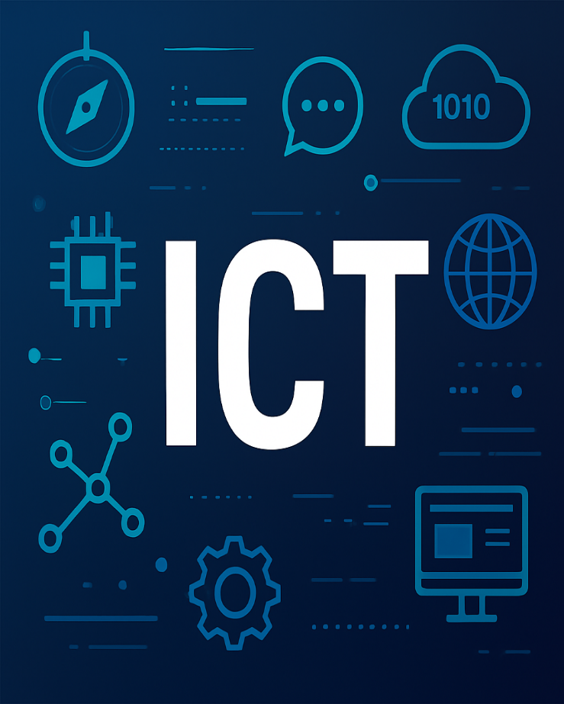  Introduction to Information and communication technology  Complete Notes
  Name | Muhammad Taha
  Roll# | 25F-0755
  Dept. | BSCS
  Section | 1B

Introduction to Information and Communication Technology

What is a Computer and What Does It Do?
A computer is a programmable electronic device that:
- Accepts data
- Performs operations on data
- Presents results
- Stores data/results as needed
Four Primary Operations of a Computer:
- Input
- Entering data into the computer (e.g., keyboard, mouse, scanner).
- Processing
- Performing operations on the input data (e.g., calculations, comparisons, decision-making by CPU)
- Output
- Presenting the results of processing (e.g., monitor, printer, speakers).
- Storage
- Saving data, programs, or output for future use (e.g., hard drive, SSD, cloud storage).

Data vs. Information:
A user inputs data into a computer, and then the computer processes it. When data is processed into a meaningful form, it becomes information.

- History / Evolution of Computers

Earliest Devices:
- Abacus → (First manual calculator with beads on rods.)
- Pascal (France) → invented the Pascaline. (first Mechanical calculator using interlocked gears , automatic gear movement.) → Pascaline → Addition & Subtraction
- Leibniz (Germany) → improved Pascal’s work → Stepped Reckoner (name of Leibniz Calculator) → All four operations (i.e. addition, subtraction, multiplication and division)
- Charles Babbage (England) → Father of the Computer. → Analytical engine, used punch cards (algorithms on paper, Punch Cards Help in Algorithms changes , like we can change the input and get another result).
Electromechanical Stage-Electronically Controlled Mechanical Relays:
- Stibitz (1940, Bell Labs) → made the first Small electromechanical calculator using relays.
- Harvard Mark-I (1944) → first big (large) electromechanical computer, automatic, built at Harvard.
ENIAC (Electronic Numerical Integrator and Computer):
Facts of ENIAC :
- Area: 1800 sq. ft
- Components: 20,000 vacuum tubes, 1500 relays, 10,000 capacitors, 70,000 registers
- Power: 200 KW
- Weight: 30 tons
- Cost: $487,000 (~62.5M PKR)
Rapid Advancements:
- Transistor → Smaller, faster, efficient.
Miniaturization:
is the process or act of making something significantly smaller in size
- Integrated Circuits (ICs) → Miniaturization.
- Moore’s Law → Processing doubles ~2 years.
Moore’s Law:
says transistors double every 2 years not automatically, but because that was the practical speed engineers and companies could sustain — faster (like 6 months) would be too hard and too expensive.
- 1976: Apple desktop (Steve Jobs & Stephen Wozniak).
- 1981: IBM PC.
- Modern Era: Web, smartphones, AI.

- Generations of Computers

Generation | Years | Technology | Features
1st | 1944–59 | Used Vacuum tubes | Huge, hot, unreliable
2nd | 1959–64 | Used Transistors | Smaller, faster
3rd | 1964–75 | ICs (LSI) | Multiprogramming
4th | 1975–… | VLSI(Very Large Scale Integrated Circuits) (microprocessor) | PCs, networking
5th | 1980–Now | ULSI (Ultra Large Scale Integration) + AI based computers | Robotics, quantum

- Modern Applications of Computer Science

- AI in Healthcare → Diagnosis, drug discovery.
- AI in Vehicles/Drones → Self-driving, delivery.
- Smartphones → Mobile computing.
- Social Media → Personalized feeds, ads.
- Video Games (VR/AR) → Immersive experiences.
- Smart Homes → IoT devices, Alexa/Google.
- Surveillance → CCTV, AI monitoring.

- Basic Components of a Computer System
- Control Unit (CU): Directs flow of data and instructions.
- Arithmetic & Logic Unit (ALU): Performs calculations and logical decisions.
- Registers: Small, very fast memory inside CPU.

- Input (keyboard, mouse)
- Output (monitor, printer)
- Storage (RAM, hard disk)
- CPU = CU + ALU + Registers (brain of computer)

- Storage Devices
👉 Shortcut to remember:
- Primary = Broad category (RAM + ROM + Cache + Registers).
- Main Memory = Just RAM (working memory).
- Volatile = Temporary memory (data lost without power) → e.g., RAM.
- Non-Volatile = Permanent memory (data saved even without power) → e.g., ROM, Hard disk.

- Primary Memory
  - Directly accessible by CPU.
  - Includes RAM + ROM + Cache + Registers.
  - Stores data + instructions needed by CPU for quick access.
  - Fast, limited in size.
  - Partly volatile (RAM), partly permanent (ROM).
- Main Memory (RAM)
- Part of Primary Memory.
- Stores currently running programs & data. (currently in use)
- Volatile → erased (lost ) data when power is off.
- Fast, as compared to secondary memory
- ROM is also main memory in some books but main working
memory is only RAM
- Examples: DRAM, SRAM.

Types of RAM:
- Secondary Memory = Permanent storage.
- Slower but larger than primary memory.
- Non-volatile (data stays even without power).
- Examples: HDD, SSD, CD, DVD, USB.

- DRAM (Dynamic RAM) → Needs refresh, slower, cheaper.
- SRAM (Static RAM) → No refresh, faster, costly (used in cache)
SRAM (Static RAM):
- Uses flip-flop circuits to store data.
- Very fast and reliable (Utilize less power and it is more expensive.).
- Does not need refreshing as long as power is on.
- Expensive and small in size.
- Used in Cache Memory (L1, L2, L3) and CPU registers.
👉 In short: Faster, costlier, used in cache.

DRAM (Dynamic RAM):
- Uses capacitors to store data (charges = 1, no charge = 0).
- Needs continuous refreshing (thousands of times per second).
- Slower than SRAM but much cheaper.
- Processor cannot access data of DRAM when it is being refreshed.
- Higher capacity → used as main system memory (RAM sticks in PCs/laptops).
👉 In short: Cheaper, larger, slower, used as main memory.

Types of ROM:
- PROM (Programmable ROM):
- Initially empty.
- User can program it once using a special device.
- Cannot be erased or re-written.
👉 In short: Write once, permanent.
- EPROM (Erasable Programmable ROM):
- Can be erased with UV light and reprogrammed.
- Used in development/testing phases
- Has a transparent quartz window to expose it to UV light.
👉 In short: Erasable with UV light, reusable.
- EEPROM (Electrically Erasable Programmable ROM):
- Can be erased and re-written electrically.
- Slower and smaller storage than modern flash.
- Used for storing small data like BIOS settings.
👉 In short: Erasable electrically, limited re-writes.

Registers:
- Registers = Fastest memory inside CPU.
- Store temporary data/instructions.
- Act as CPU’s working desk for execution. (Data is transferred from main memory (RAM) into registers for execution)
- CPU contains several registers, each with a predefined function.
- Types → Special Purpose & General Purpose.
Cache Memory:
- Pronounced as “cash”.
- Very fast memory, faster than RAM.
- Stores most recently or frequently used data for the CPU.
- On first use, CPU retrieves data from RAM.
- A copy of the data is stored in cache.
- On next use, CPU checks cache first:
- If data is found → retrieved from cache (faster).
- If not → retrieved from RAM again.

Relative Fast (speediness):
Registers (Fastest, smallest, inside CPU) → Cache (stores most recent/frequent data) → RAM → Secondary → Tertiary
Trick:
R → C → R → S → T
(RCRST)

Direct Memory Access (DMA):
Definition: A technique that allows peripheral devices (like hard drives, SSDs, or network cards) to transfer/access data directly to/from main memory (RAM) without involving the CPU.
Purpose: To speed up data transfer/access and free the CPU to perform other tasks.
How it Works:
- CPU sets up DMA controller with:
  - Source address (device or memory)
  - Destination address (memory or device)
  - Amount of data to transfer
- DMA controller handles the actual data transfer directly between device and RAM.
- CPU is free during the transfer, only gets interrupted when the transfer is complete.
Advantages of DMA:
- Faster data transfer than CPU-managed transfers.
- Reduces CPU overhead.
- Efficient for large data blocks (like audio, video, disk I/O).
Quick Notes (Quiz-Ready):
- DMA = Direct Memory Access.
- Transfers data directly between device ↔ RAM without CPU involvement.
- CPU only sets it up and is free during transfer.
- Faster & more efficient, used in disks, network cards, audio/video devices.
Storage Memory Heirarchy:
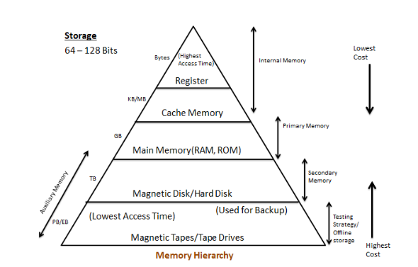
Processing Device / CPU (Central Processing Unit):
- Definition: The brain of the computer that processes instructions and data.
- CPU is located on motherboard.
- Performs all calculations, logic decisions, and controls other components.
Main Components of CPU:
- Control Unit (CU)
  - Directs flow of data and instructions between memory, input, output, and ALU.
  - Manages execution of programs.
- Arithmetic & Logic Unit (ALU)
  - Performs arithmetic operations (add, subtract, multiply, divide).
  - Performs logical operations (AND, OR, NOT, comparisons).
- Registers
  - Small, high-speed storage inside CPU.
  - Temporarily holds data, instructions, or addresses being processed.

In short:
- CPU = Processing Device / Brain of Computer.
- CU = controls data flow & program execution (manager)
- ALU = calculator (performs arithmetic & logic operations)
- Registers → tiny high-speed storage inside CPU (for immediate work)
- Works in fetch → decode → execute → store cycle
The Machine Cycle
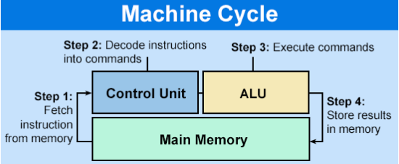
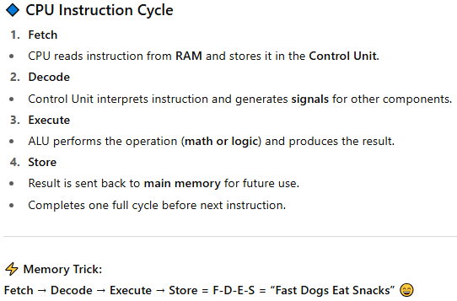
Motherboard (Main Circuit Board):
- Definition: The main printed circuit board (PCB) of a computer that connects all components together.
- Acts as the backbone of the computer, allowing communication between CPU, memory, storage, and peripherals.
Key Components on Motherboard:
- CPU Socket → Holds the processor (CPU).
- Memory Slots → For RAM / Main Memory modules.
- Chipset → Manages data flow between CPU, RAM, and peripherals.
- Expansion Slots → For graphics cards, network cards, sound cards (PCI, PCIe).
- Storage Connectors → SATA, NVMe slots for HDD, SSD, Optical drives.
- Power Connectors → Supply electricity to motherboard and components.
- Input/Output Ports → USB, HDMI, Ethernet, Audio, etc.
- BIOS/UEFI Chip → Stores firmware for booting the computer.
Functions of Motherboard:
- Provides physical platform for components.
- Enables communication between CPU, memory, storage, and peripherals.
- Supplies power to components via connectors.
- Houses BIOS/UEFI for system initialization.
Quick Notes (Quiz-Ready):
- Motherboard = main circuit board connecting all components. (Holds CPU and connects all subsystems.)
- Contains: CPU socket, memory slots, chipset, expansion slots, storage connectors, I/O ports.
- Function: Provides power, communication, and platform for all hardware.

System Bus:
- Definition: A set of parallel wires (pathways) that allows data, instructions, and control signals to flow between CPU, memory, and peripherals.
- Think of it as the communication highway of the computer.
Types of System Buses:
- Data Bus
  - Carries actual data between CPU, memory, and I/O devices.
  - Bidirectional (data can go both ways).
  - Width (number of wires) affects how much data can be transferred at once.
- Address Bus
  - Carries memory or device addresses where data should be read/written.
  - Unidirectional (CPU → Memory/Device).
  - Width determines maximum addressable memory.
- Control Bus
  - Carries control signals to coordinate operations.
  - Signals include Read, Write, Clock, Interrupts.
  - Ensures devices act at the right time.
Quick Notes (Quiz-Ready):
- System Bus = Communication highway of CPU, memory, and I/O.
- Data Bus: Transfers actual data.
- Address Bus: Transfers memory/device addresses.
- Control Bus: Transfers control signals to synchronize operations.
- Width & speed of buses affect overall computer performance.
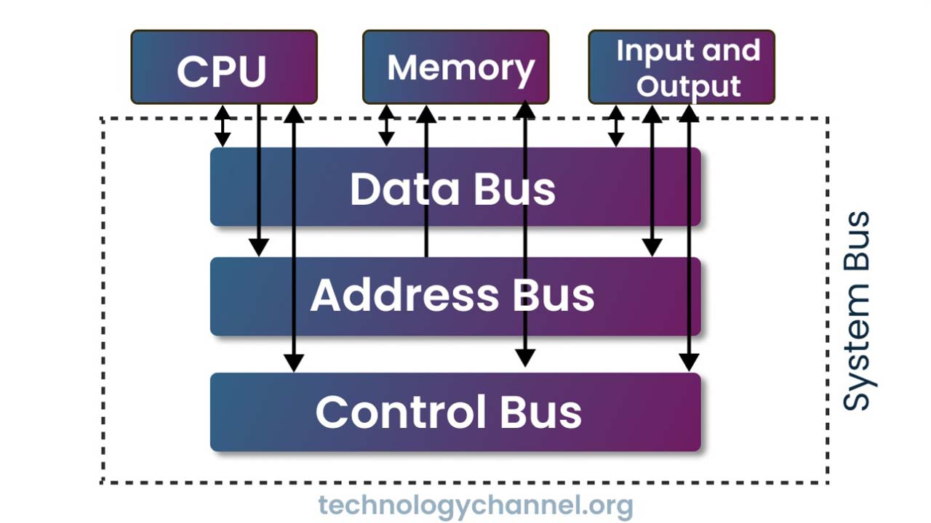

Interrupts:
- Definition: A signal sent to the CPU by a device or software to get the CPU’s attention.
- It temporarily pauses the current program so the CPU can handle an urgent task.
- After handling, CPU resumes the original program.
Types of Interrupts:
- Hardware Interrupts
  - Generated by hardware devices like keyboard, mouse, printer, or disk.
  - Example: Pressing a key → keyboard sends interrupt to CPU.
- Software Interrupts
  - Generated by programs or software to request CPU services.
  - Example: System call in an OS.
Working of Interrupts:
- Device or software sends an interrupt signal to CPU.
- CPU saves the current state of execution.
- CPU executes the Interrupt Service Routine (ISR) to handle the interrupt.
- After completion, CPU resumes the previous task.
Advantages of Interrupts:
- Efficient CPU usage → CPU doesn’t waste time waiting for devices.
- Immediate attention to urgent tasks.
- Enables multitasking and real-time processing.
Quick Notes (Quiz-Ready):
- Interrupt = Signal to CPU to pause current task and handle urgent event.
- Types: Hardware (keyboard, mouse) and Software (program requests).
- CPU executes ISR, then resumes previous program.
- Purpose: Efficient CPU usage & faster response to devices.
Software:
A set of programs, instructions, and data that tells the computer what to do.
Software = Intangible → cannot be touched physically like hardware.
Types:
- System Software: OS & utilities → manages computer.
- Application Software: User tasks → Word, Excel, games.
- Programming Software: Helps create programs → compiler, IDE.
In short, system software makes the hardware usable while application software handles specific tasks.
Hardware:
The physical components of a computer that you can see and touch.
- Hardware executes instructions provided by software.
------
- Hardware = Physical components of computer.
- Works according to software instructions.
- Types: Input(keyboard,etc), Output(monitor,printer), Storage(Hdd,sdd), Processing(CPU, ALU), Communication(Modem, Network Card, Router). Devices.
- Tangible → can touch physically.
Language of a computer:
- Computers use digital signals (0s & 1s) → machine language.
- Digital → 0 = low voltage,
→ 1 = high voltage.
- Bit = 0 or 1, sequences of bits form binary code.
- From a shortening of the words “binary digit”
- Bit = 1 binary digit.
- Binary code = sequences of bits form binary code .
- ASCII: 7-bit code, 128 characters, e.g., A = 1000001.
- Assembly Language: Human-friendly, needs assembler to convert to machine code.
- High-Level Languages: English-like instructions, need compiler + linker + loader to run.
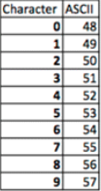
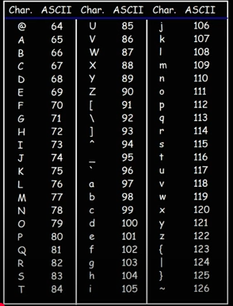
Programming Levels:
- Machine Language → Binary only.
- Assembly Language → Mnemonics, needs assembler.
- High-Level Languages (HLLs) → C, C++, Java, closer to English.
Tools:
- Assembler → Assembly → Machine code.
- Compiler → HLL → Machine code.
- Linker → Combines object + libraries.
- Loader → Loads executable into RAM.
ASCII (American Standard Code for Information
Interchange):
ASCII = decimal number
then we convert decimal number into binary
code(number) by two ways:
Method 1: Division by 2 (Repeated Division):
Steps:
- Divide the decimal number by 2.
- Write down the remainder (0 or 1).
- Divide the quotient by 2 again.
- Repeat until the quotient becomes 0.
- Binary number = remainders read from bottom to top. ( write remainders bottom to top.)
Method 2: Subtraction (Place Value):
Steps:
- Write powers of 2 ≤ decimal number: 8, 4, 2, 1
- Subtract the largest possible power of 2 from the number and mark 1.
- Mark 0 for powers not used.
- Binary = sequence of 1s and 0s from highest to lowest power.
Example: 13 → 8 + 4 + 0 + 1 → Binary = 1101
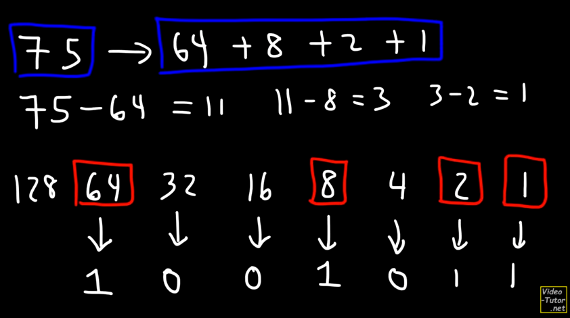

EXAMPLE:
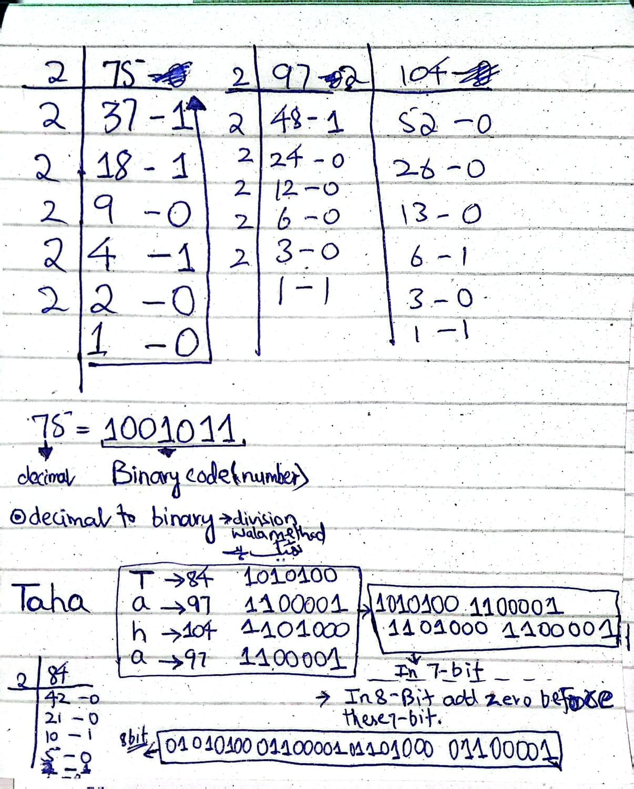
- 7-bit mai ans aye ga so inko agr 8 bits mai krna tu each decimal ka binary ka start mai 0 laga do simple.

Data Units in Computers:
- Bit = smallest data unit (0 or 1)
- 1 Byte = 8 bits
- Each keyboard character is stored as a Byte (Example A = 01000001)
- Data increases by 1024 (2¹⁰) times at each level (KB → MB → GB → TB → PB)
- Common usage:
- KB → text files
- MB → images, documents
- GB → videos, software
- TB → hard disks, cloud storage
- This can vary file quality or quantity wise. (that’s just the
Bits → Bytes → Kilo → Mega → Giga → Tera → Peta

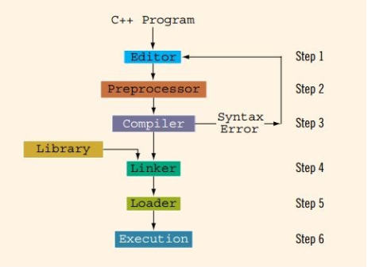

Information System
- An Information System is a combination of people, technology, processes, and data that work together to collect, process, store, and distribute information.
- Purpose: To support decision-making, coordination, control, analysis, and visualization in an organization.
Components of an Information System:
- Hardware – Physical devices (CPU, memory, storage, input/output devices).
- Software – Programs and applications that process data.
- Data – Raw facts that are processed into meaningful information.
- People – Users who interact with the system (managers, IT staff, employees).
- Processes / Procedures – Rules and methods to operate the system efficiently.
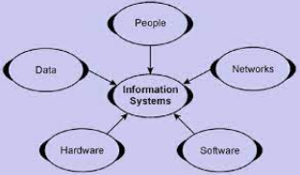

Hardware:
The physical components of a computer that you can see and touch.
- Hardware executes instructions provided by software.
------
- Hardware = Physical components of computer.
- Works according to software instructions.
- Types: Input(keyboard,etc), Output(monitor,printer), Storage(Hdd,sdd), Processing(CPU, ALU), Communication(Modem, Network Card, Router). Devices.
- Tangible → can touch physically.

Software:
A set of programs, instructions, and data that tells the computer what to do.
Software = Intangible → cannot be touched physically like hardware.
Types:
- System Software: OS & utilities → manages computer.
- Application Software: User tasks → Word, Excel, games.
- Programming Software: Helps create programs → compiler, IDE.
In short, system software makes the hardware usable while application software handles specific tasks.

- Nowadays, storage services are offered from the cloud, which can be accessed from telecommunications networks.

Data Storage Technologies

Data Storage Technology = Method & device to store digital data.
- Provide structures and models to store, retrieve, and analyze data efficiently.
- Main Categories:
- Relational Databases
- NoSQL Databases
- Data Warehouses
Relational Databases (RDBMS):
- Store structured data in tables (rows & columns).
- Reliable with strong data integrity.
- Used for transactional applications.
- Examples: MySQL, Oracle, SQL Server
NoSQL Databases:
- Stands for “Not Only SQL”.
- Designed for unstructured and semi-structured data.
- Types:
  - Document (e.g., MongoDB)
  - Key-Value (e.g., Redis)
  - Column-family (e.g., Cassandra)
  - Graph
- Features: Flexible schema, highly scalable
- Examples: MongoDB, Cassandra, Redis
Data Warehouses:
- Central repository for large volumes of structured data from multiple sources (databases, files, apps).
- Stores historical data for business intelligence and analytics.
- Examples: Amazon Redshift, Snowflake, Google BigQuery
- Use Case:
  - Amazon collects sales data from all countries → managers analyze to decide which products to promote in which region.

Comparison
Type | Features / Usage | Examples
Relational Databases | - Store structured data in tables (rows & columns).  - Reliable with strong data integrity.  - Used for transactional applications. | MySQL, Oracle, SQL Server
NoSQL Databases | - Stands for “Not Only SQL”.  - Designed for unstructured and semi-structured data.  - Features: Flexible schema, highly scalable | MongoDB, Cassandra, Redis
Data Warehouses | Stores historical data from multiple sources for business intelligence and analytics  Analytical, historical, supports BI tools | Amazon Redshift, Snowflake, BigQuery

Information System (Networks/Computer Networks)

Quick Notes (Quiz-Ready):
- Network = Connected computers/devices sharing resources.
- Purpose: Share data, communication, collaboration, access resources.
- Types: LAN, WAN, MAN, PAN, CAN
- Components: Router, Switch, Hub, Modem, Cables/Wi-Fi
Types of Networks:
Sr. | Type | Description | Example
1. | LAN (Local Area Network) | Small area network, e.g., home, office | Home Wi-Fi, office network
2. | WAN (Wide Area Network) | Covers large areas, countries, or continents | Internet, corporate networks
3. | MAN (Metropolitan Area Network) | Covers a city or town | City government networks
4. | PAN (Personal Area Network) | Very small network, personal devices connected | Bluetooth devices, smartphone + laptop
5. | CAN (Campus Area Network) | Covers university or company campus | University campus network
Transmission Modes:
- Wired Networks: Use physical cables to transmit data.
  - Examples: Fiber optic cables, Coaxial cables
- Wireless Networks: Use electromagnetic signals to transmit data.
  - Examples: Radio waves, Microwaves, Wi-Fi

Information System (People)

- Role of People in IS
- Users and stakeholders interact with the information system.
- Provide input, operate the system, and make decisions based on information.

- Feedback Mechanism
- Information systems often include mechanisms to collect feedback from:
  - Users
  - Other sources (e.g., sensors, logs)
- Purpose of Feedback:
  - Improve system performance
  - Enhance effectiveness
  - Identify errors or inefficiencies
3. Quick Notes (Quiz-Ready)
- People = Users / Operators / Decision-makers in IS
- Feedback = Input from users & sources
- Goal: Improve performance and effectiveness of the system
Need for Information System (IS):
- Fast and Accurate Information
- Fast Communication Network
- Support for Decision-Making
- Helps managers and decision-makers to:
- Analyze data
- Make informed decisions
- Plan and control operations effectively
- Reduction in Information Load
- Filters and organizes data to prevent information overload.
- Ensures relevant information is delivered to the right person at the right time.

Common Number Systems
Number system can be categorized as:
- Decimal number system
- Binary number system
- Octal number system
- Hexadecimal Number System

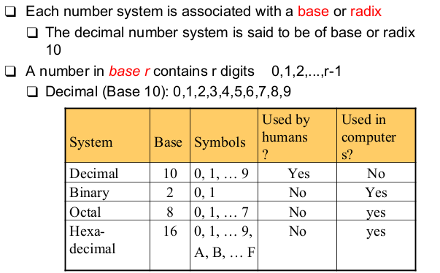

Number Conversions [(binary, decimal, octa decimal, Hexadecimal)
Number System Conversion:
- Decimal (Base 10)
- Uses digits 0–9.
- Example: 245₁₀
- Binary (Base 2)
- Uses digits 0 and 1.
- Example: 1011₂
- Octal (Base 8)
- Uses digits 0–7.
- Example: 17₈
- Hexadecimal (Base 16)
- Uses digits 0–9 and A–F (where A=10 … F=15).
- Example: 1A₁₆
Conversion:
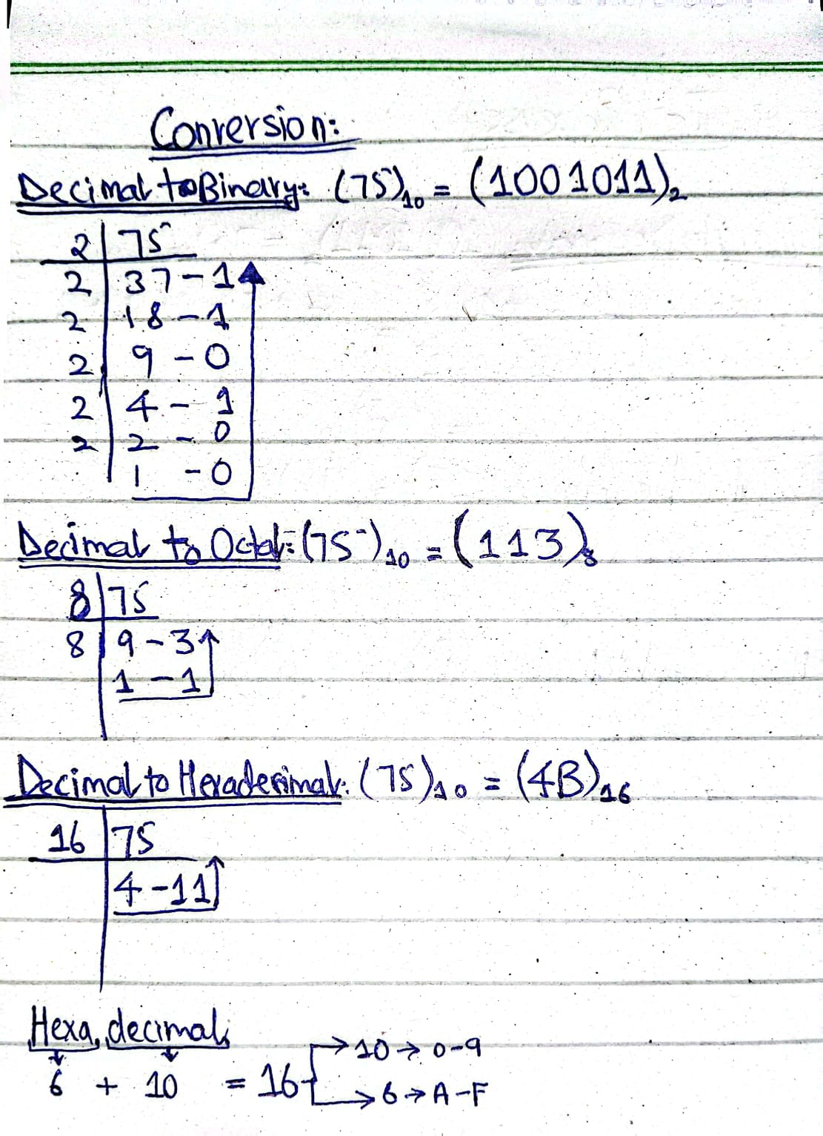

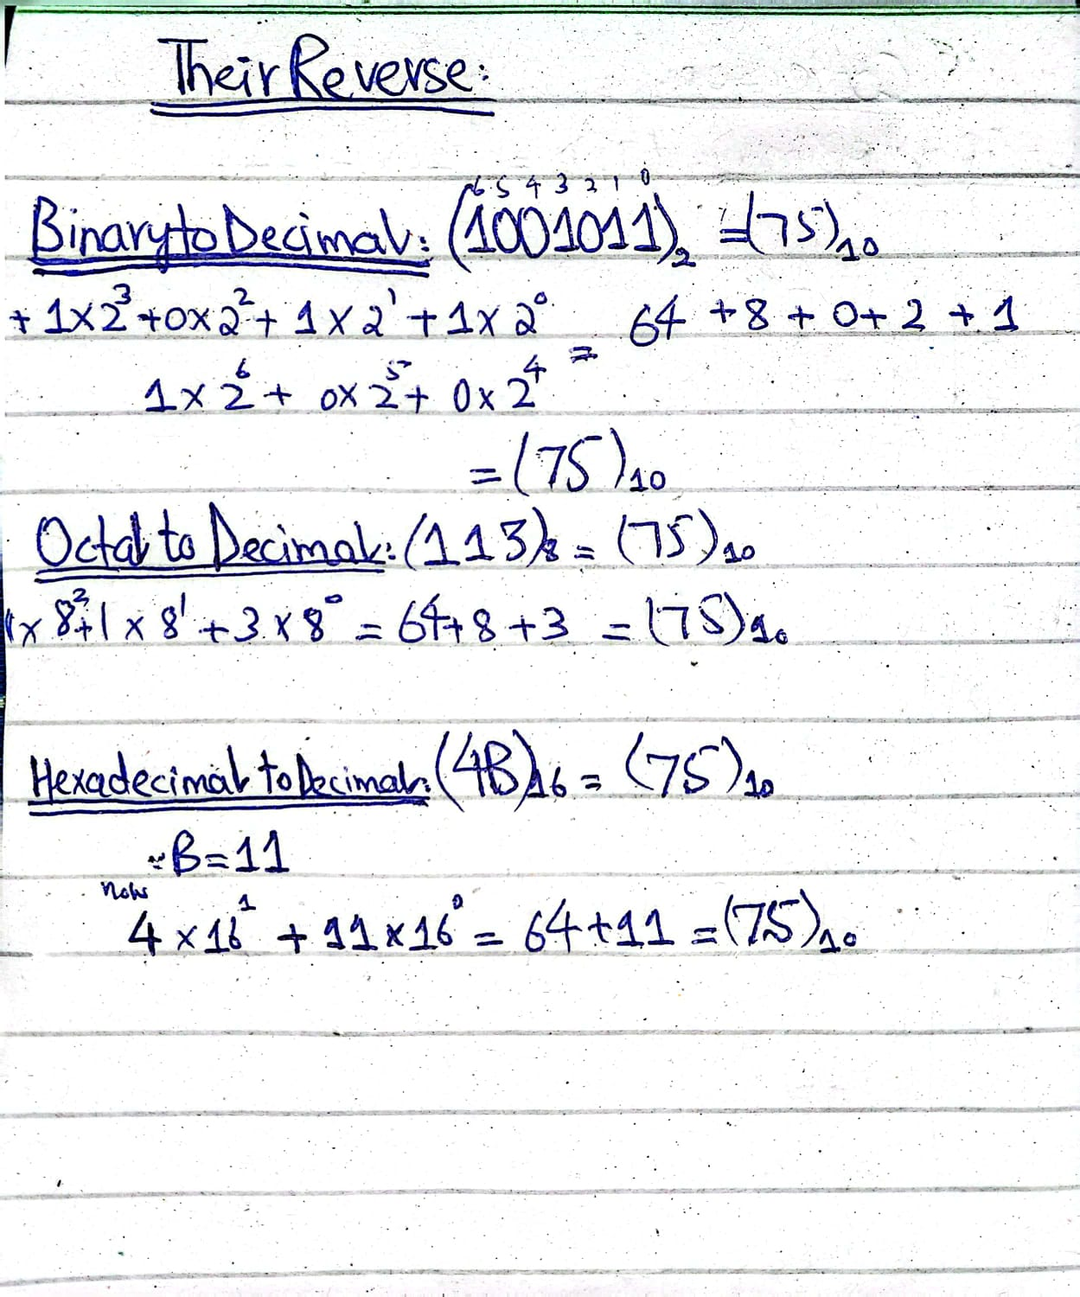
- Convert (from decimal into binary, octal, hexadecimal, etc.) using division by base.

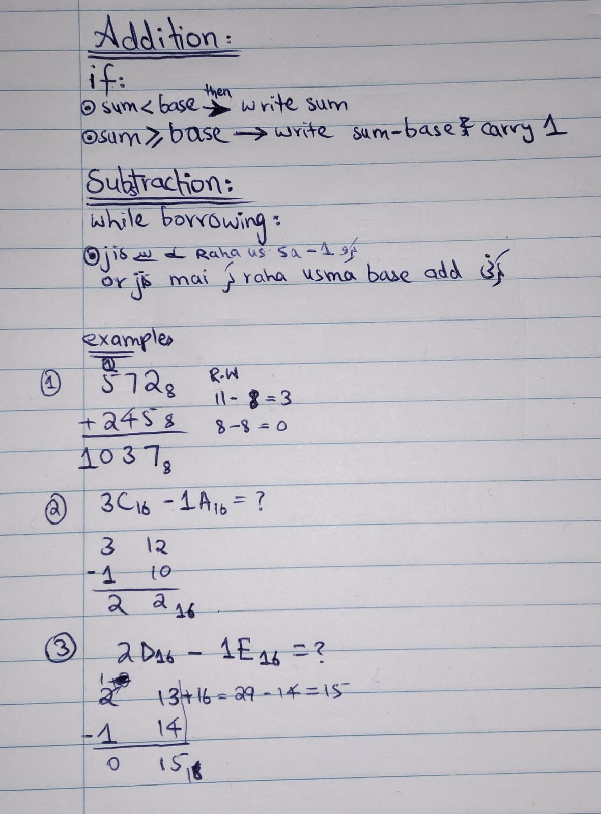

For Multiplication and division → convert the number in the decimal then do multiplication / division and then convert back into original number system.

1. One’s Complement:
One’s complement of a binary number is obtained by inverting all bits:
- 0 → 1
- 1 → 0

How to Find 1’s Complement
Just flip every bit.
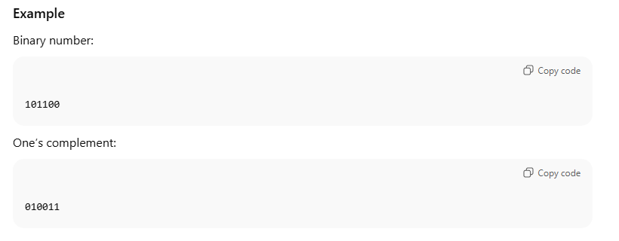
2. Two’s Complement:

Two’s complement is obtained by:
- Taking 1’s complement
- Adding 1 to the result (i.e. add 1 to the least significant bit i.e. to the right one)
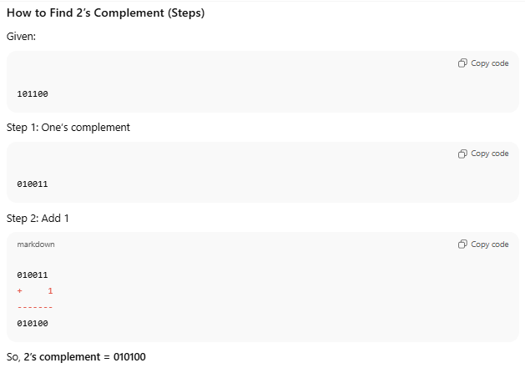
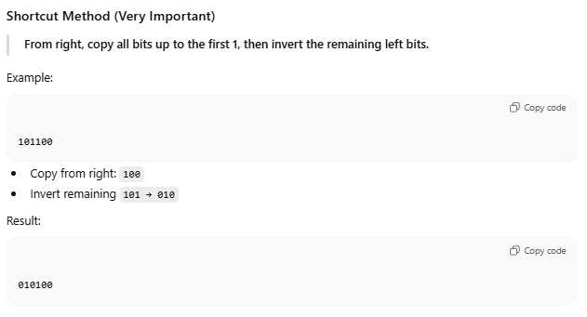
Like from the right when the first 1 (pahla 1) aye tu stop coping then remaining part ko invert kr do
Fractions in Number System (point mai)
There are two parts to handle:
- Integer part (whole number to the left of the decimal point)
- Fractional part (decimal portion to the right of the decimal point)
Steps of conversion:
- Integer Part Conversion:
Convert (from decimal into binary, octal, hexadecimal, etc.) using division by base (uski base jis mai convert kr raha hain) (and then arranging remainders from bottom to top).
- Fractional Part Conversion:
Convert using multiplication by base (uski base jis mai convert kr raha hain). (and then arranging the integers from top to bottom)
- Combine Both

IEEE (Institute of Electrical and Electronics Engineers)
IEEE is a professional organization that sets standards for electronics, electrical, and computer engineering technologies, including floating-point representation in computers.

1. Common Conversion Steps (Same for ALL):
No matter whether it is half, single, or double precision, you always:
- Convert decimal → binary
- Normalize → 1.x×2 ki power e (exponent)
- Determine sign bit
- Calculate biased exponent → e + bias
- Write mantissa (fraction only)
Format Comparison (MEMORIZE THIS TABLE)
Precision | Total Bits | Sign | Exponent | Mantissa (Fraction) | Bias
Half (IEEE-754) | 16 | 1 | 5 | 10 | 15
Single (IEEE-754) | 32 | 1 | 8 | 23 | 127
Double (IEEE-754) | 64 | 1 | 11 | 52 | 1023
Quadruple (IEEE-754) | 128 | 1 | 15 | 112 | 16383
Bias formula = [2^(k-1)] – 1
Where k = number of exponent bits

2. Decoding (Reverse Conversion)
Same idea:
- Read sign
- Exponent − bias
- Add implicit 1. before mantissa
- Multiply by 2^e
✔ Bias depends on precision
✔ Mantissa length depends on precision

FAST-NUCES Exam Tip
If the question says:
- If a question says “IEEE”, it almost always refers to floating-point representation.
- “IEEE-754” only → assume single precision
- “Half / Single / Double” mentioned → use correct bias + bits
- Always write bias value to avoid losing marks
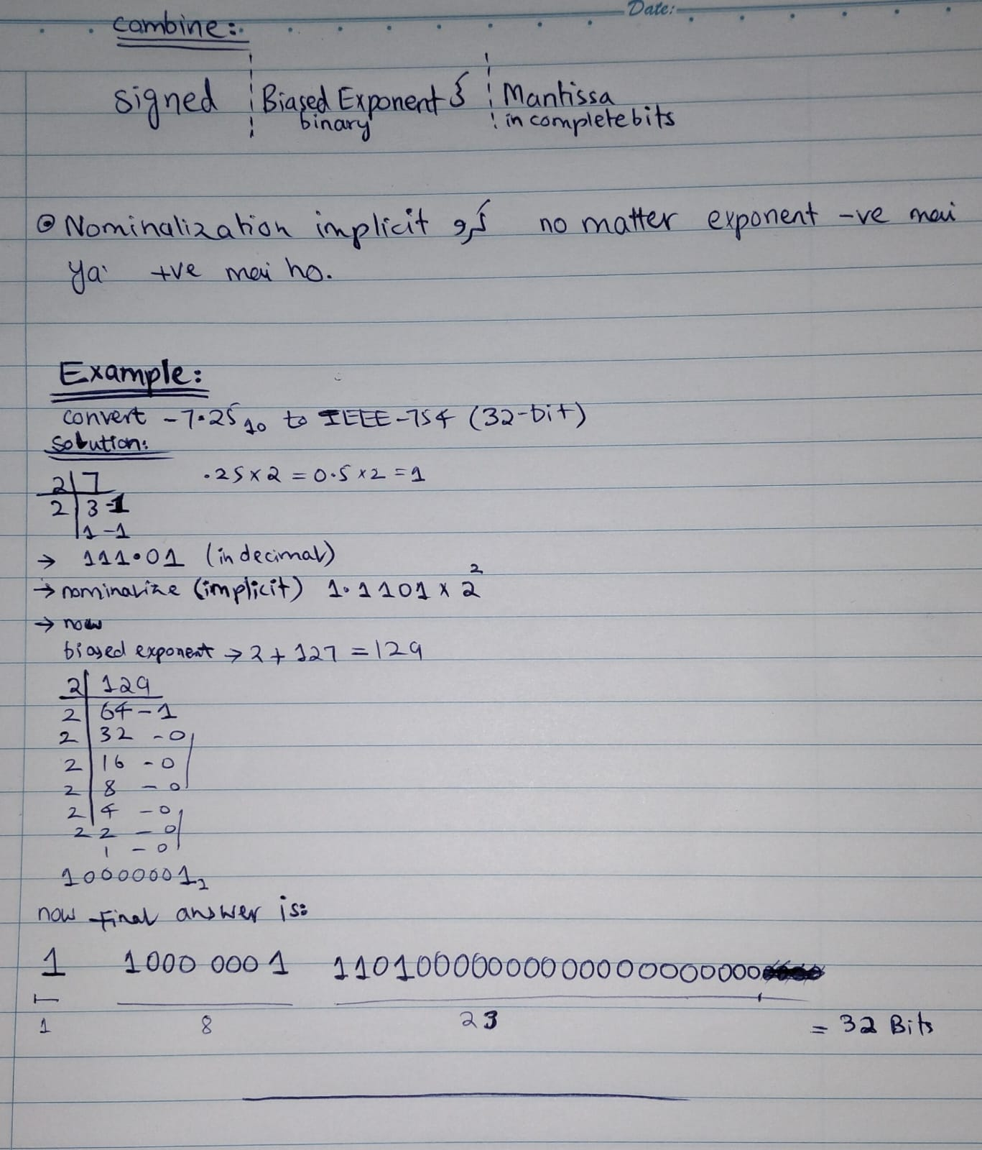

ASCII
ASCII = American Standard Code for Information Interchange
It is a standard encoding that represents characters (letters, digits, symbols) as numbers, which can then be stored in binary.
HOW TO FIND ANY WORD BECOMING BY BINARY:
(agr koi binary di ho long tu un mai 8 , 8 bits ka group bana laina or prh usko decimal mai convert krna then vo ascii hai so us decimal sa jo banta ho vo bana daina)
Each character in original ASCII = 7 bits
Each character in extended ASCII = 8 bits → use 8 bit extended ascii
Key ASCII Ranges
Decimal | Character Type
0–31 | Control characters (e.g., newline, tab)
32–47 | Symbols (space, ! " # …)
48–57 | Digits 0–9
65–90 | Uppercase A–Z
97–122 | Lowercase a–z
128–255 | Extended symbols (extended ASCII)

3. How to Convert Binary → Text Using ASCII

Step 1: Split the binary number
- If 8-bit ASCII, split into 8-bit groups
- Example: 01001000 01101001

Step 2: Convert each binary group to decimal
- 01001000 → 72
- 01101001 → 105

Step 3: Look up the ASCII table
- 72 → H
- 105 → i

Step 4: Combine characters
01001000 01101001 → Hi

Quick Binary-to-Text Example
Binary:
01000001 01000010 01000011
Step 1: Split → 8-bit groups
Step 2: Convert to decimal: 65, 66, 67
Step 3: Look up ASCII table → A, B, C
Answer: ABC

FAST Exam Tips
- Always split binary correctly (7 or 8 bits)
- Use decimal conversion first, then ASCII
- Remember key ranges:
  - 48–57 → 0–9
  - 65–90 → A–Z
  - 97–122 → a–z

